FACULTY EVALUATION
Programme Name: SBVP ALUMNI MASTERCLASS - GROW Online Tanzania (23rd March 2026 - 27th March 2026)
Session: Long-term sustainability planning
Faculty Name: Dr. Geoffrey Ikavulu Injeni
No. of Respondents: 9
No. of Participants: 10
Evaluation Parameter | (%) Individual Score | (%) Programme Average
Punctuality (Commencement and Completion of Sessions) | 96 | 96
How well do you understand the core concepts presented? | 93 | 95
Rate your confidence in applying the new skills learnt | 91 | 95
Degree of Faculty preparedness for the sessions | 93 | 96
Content and methodology of the program | 96 | 97
Quality of class and group discussions | 96 | 95
The information presented in the course is relevant to my work (ministry) | 91 | 94
Average scores | 94 | 95

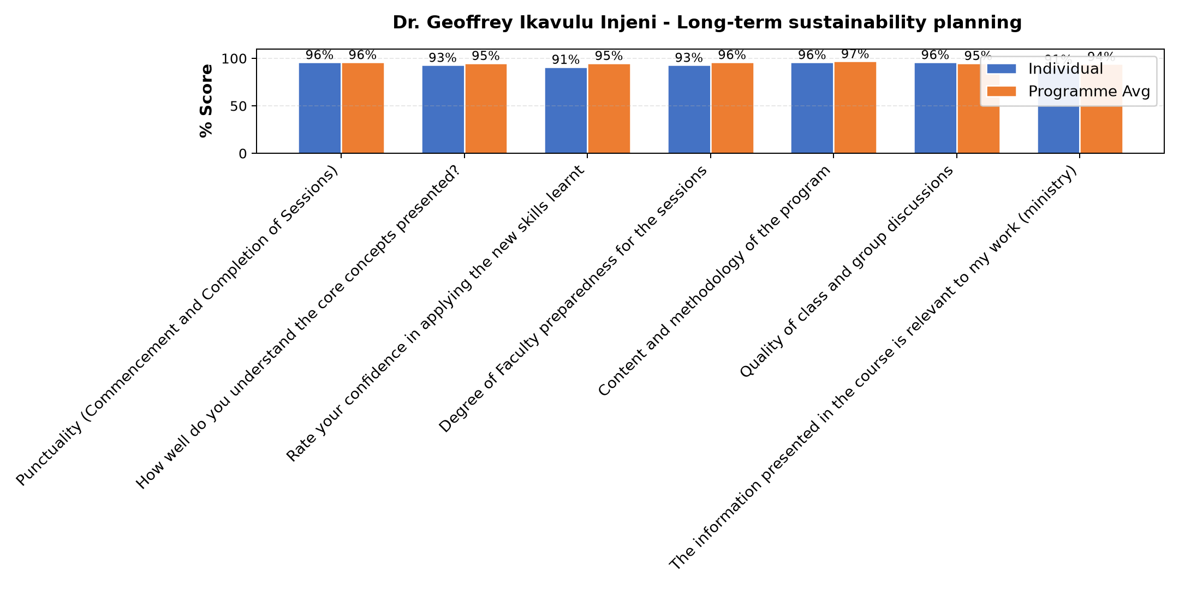

Comments & Feedback
- • Poor management of our social enterprise.
- • Poor business plan
- • Internet
- • Well understood
- • Thanks
- • During cession was internet problem
- • He has given us good direction.
- • She has tried to take us back on what we have learned and to make us reflect on the Our business.
SUBMITTED THROUGH:
SBS Evaluation Automation System

